**Advance DevOps lab**

**Experiment 8**

**Name: BALOCH MUZAMMIL HAFEEZ ROLL NO: 612012**

**Semester: V**

**Branch: Information Technology**

1. **What is hub.docker.com?**

**Ans:** Docker Hub is the world's largest repository of container images, featuring material from container community developers, open source projects, and independent software vendors (ISV) who produce and distribute their programmes in containers. Users can select between free public repositories for storing and sharing photographs and a subscription plan for private repositories.

1. **What is docker hub used for?**

**Ans:** Docker Hub is a service provided by Docker that allows you to search and share container images with your team. It is the world's largest repository of container images, with content coming from a variety of sources, including container community developers, open source projects, and independent software vendors (ISV) who build and distribute their code in containers.

Users have access to free public repositories for storing and sharing photos, or they can subscribe to private repositories.

Docker Hub includes the following key features:

* Push and pull container images from repositories.
* Teams and Organizations: Control access to private container image repositories.
* Docker Official Images: Download and utilise high-quality Docker container images.
* Docker Verified Publisher Images: Download and use high-quality container images from third-party suppliers.
* Builds: Build container images from GitHub and Bitbucket and submit them to Docker Hub automatically.
* Webhooks: To integrate Docker Hub with other services, trigger actions following a successful push to a repository.

1. **Install docker on AWS EC2 –Ubuntu by using curl.**

Step 1: Create an Ubuntu EC2 instance and connect to it (through MobaXterm)

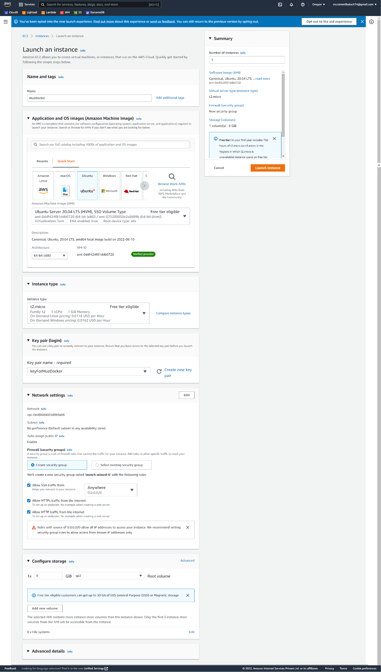

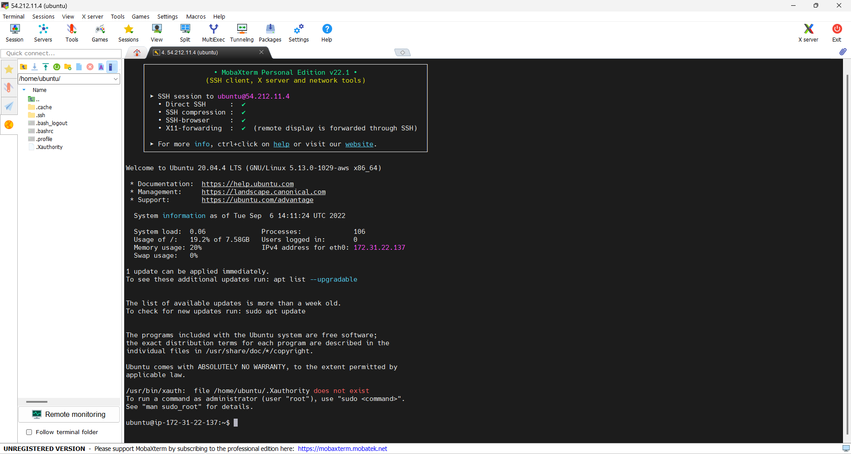

Step 2: installation of docker using curl.

Run the following commands

|  |
| --- |
| #curl -fsSL https://get.docker.com -o get-docker.sh #sh get-docker.sh |

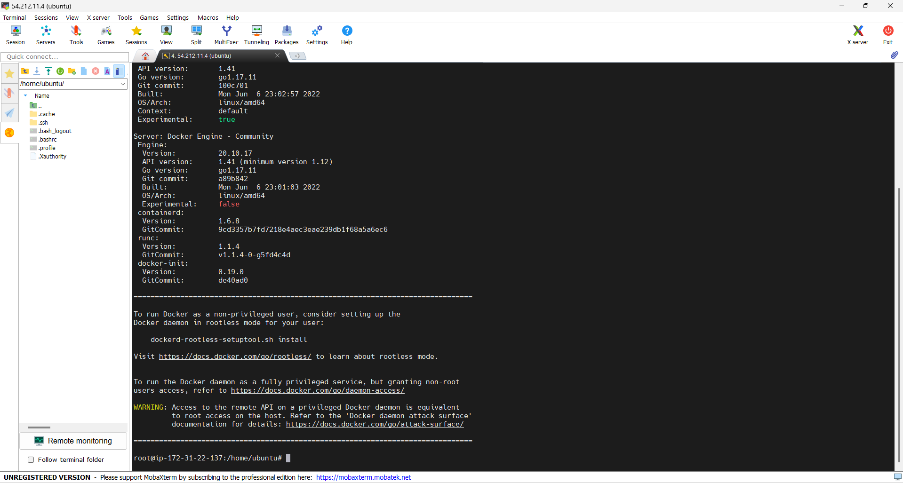

1. **Run hello-world from docker hub and explain the steps.**

Using the command #docker run hello-world

It will first try to find the hello-world image, and if it is not found, it will automatically pull it and run it.

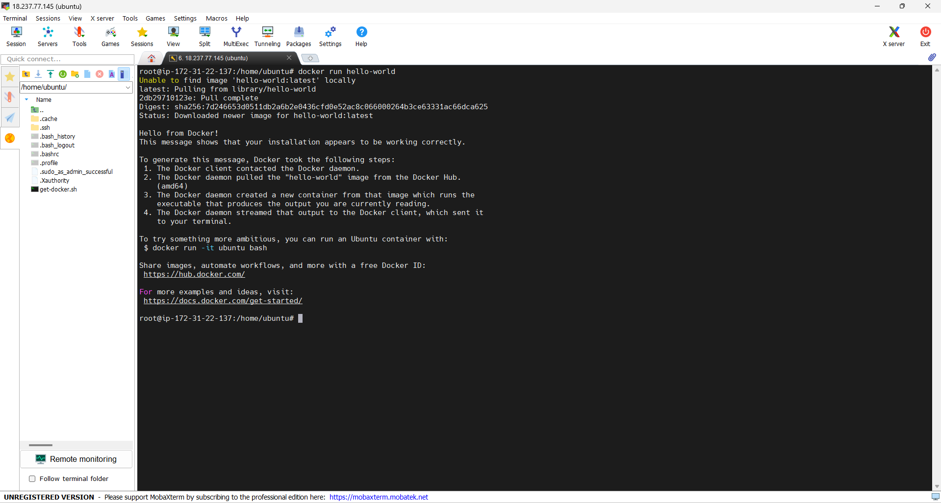

1. **Pull 3 or 4 images ,one of the python, run “ Hello World “ inside the container.**

Step 1: Pulling 3 to 4 images including python.

|  |
| --- |
| #docker pull hello-world #docker pull alpine #docker pull nginx #docker pull python #docker images |

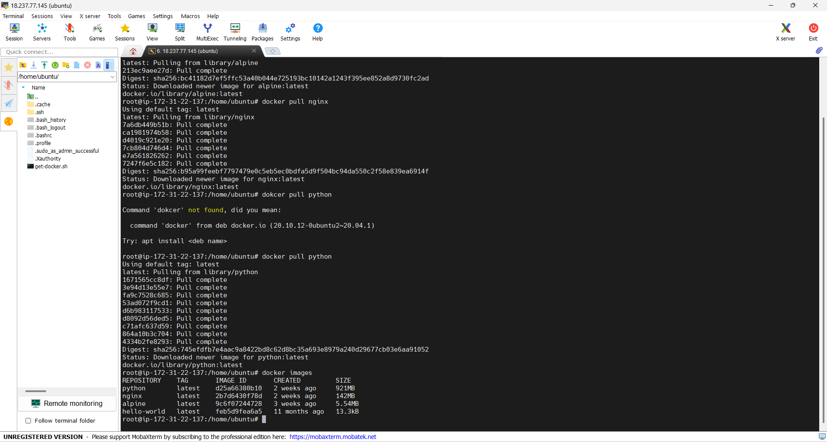

Step 2: Running hello world inside the container.

1. **Demonstrate any 15 docker commands and explain its uses.**

|  |
| --- |
| 1. docker -version   This command is used to get the currently installed version of docker.   1. docker search It is used to search for public images on the Docker hub. 2. docker pull It is used to pull image from docker hub. 3. docker images It is used to view images in our local machine.      1. docker run It is used for creating a container and running the image in it. 2. docker ps We can list all the running containers by using it. 3. docker stop  We can use it to stop a container. 4. docker ps -a Using it we can list the running containers as well as stopped once.      1. docker restart We can restart our stopped containers using this command.      1. docker rename It lets us change the container's name. 2. docker exec   It is used to execute a container.   1. docker logs It can be used to fetch logs from a specific container. 2. docker logs -follow It can be used if we want a continuous stream of output.      1. docker rm We can use this command to remove a container. 2. docker rmi This is used to remove image from the local machine. |